**Report “Lab 8-9”**

**Anton Tserakhau**

## ETL Transportation – Example of Loading FCT_*

## Task 02: Prepare Table of Facts to DW Layer

I have created required objects on DW layers and realize load process for Facts.

1. I have created tablespaces, user and granted all required privileges.

CREATE TABLESPACE "TS_STAGE_DATA_01"

DATAFILE 'db_qpt_stage_data_01.dat'

SIZE 200M

AUTOEXTEND ON NEXT 100M

/

CREATE TABLESPACE "TS_STAGE_IDX_01"

DATAFILE 'db_qpt_stage_idx_01.dat'

SIZE 50M

AUTOEXTEND ON NEXT 25M

/

CREATE TABLESPACE "TS_STAGE_TEMP_01"

DATAFILE 'db_qpt_stage_temp_01.dat'

SIZE 50M

AUTOEXTEND ON NEXT 25M

/

CREATE USER "U_DW_STAGE"

identified by "%PWD%"

default tablespace ts_stage_data_01

temporary tablespace ts_stage_temp_01

QUOTA UNLIMITED ON ts_stage_data_01

QUOTA UNLIMITED ON ts_stage_temp_01

QUOTA UNLIMITED ON ts_stage_idx_01

/

GRANT CONNECT,RESOURCE TO "U_DW_STAGE"

/

grant select on u_dw_ext_references.CLS_CNTR2GROUPING_ISO3166 to u_dw_stage;

grant select on u_dw_ext_references.CLS_CNTR_GROUPING_ISO3166 to u_dw_stage;

grant select on u_dw_ext_references.CLS_GEO_COUNTRIES2_ISO3166 to u_dw_stage;

grant select on u_dw_ext_references.CLS_GEO_COUNTRIES_ISO3166 to u_dw_stage;

grant select on u_dw_ext_references.T_EXT_CNTR2STRUCTURE_ISO3166 to u_dw_stage;

grant select on u_dw_ext_references.T_EXT_CNTR_GROUPING_ISO3166 to u_dw_stage;

grant select on u_dw_ext_references.T_EXT_GEO_COUNTRIES2_ISO3166 to u_dw_stage;

grant select on u_dw_ext_references.T_EXT_GEO_STRUCTURE_ISO3166 to u_dw_stage;

grant select on u_dw_ext_references.CLS_CNTR2STRUCTURE_ISO3166 to u_dw_stage;

grant select on u_dw_ext_references.CLS_GEO_STRUCTURE_ISO3166 to u_dw_stage;

grant select on u_dw_ext_references.T_EXT_CNTR2GROUPING_ISO3166 to u_dw_stage;

grant select on u_dw_ext_references.T_EXT_GEO_COUNTRIES_ISO3166 to u_dw_stage;

grant select on u_dw_ext_references.CLS_LANGUAGES_ISO693 to u_dw_stage;

grant select on u_dw_ext_references.CLS_LNG_MACRO2IND_ISO693 to u_dw_stage;

grant select on u_dw_ext_references.T_EXT_LANGUAGES_ISO693 to u_dw_stage;

grant select on u_dw_ext_references.T_EXT_LNG_MACRO2IND_ISO693 to u_dw_stage;

grant select on u_dw_ext_references.T_EXT_DISHES to u_dw_stage;

grant select on u_dw_ext_references.CLS_DISHES to u_dw_stage;

grant select on u_dw_ext_references.TEMP_CITY_ADDR to u_dw_stage;

grant select on u_dw_ext_references.CLS_RESTAURANTS to u_dw_stage;

grant select on u_dw_ext_references.CLS_OPERATIONS to u_dw_stage;

grant select on U_DW_EXT_REFERENCES.CLS_PERIODS to U_DW_STAGE;

1. I have created all required objects on Stage Layer and sequences:

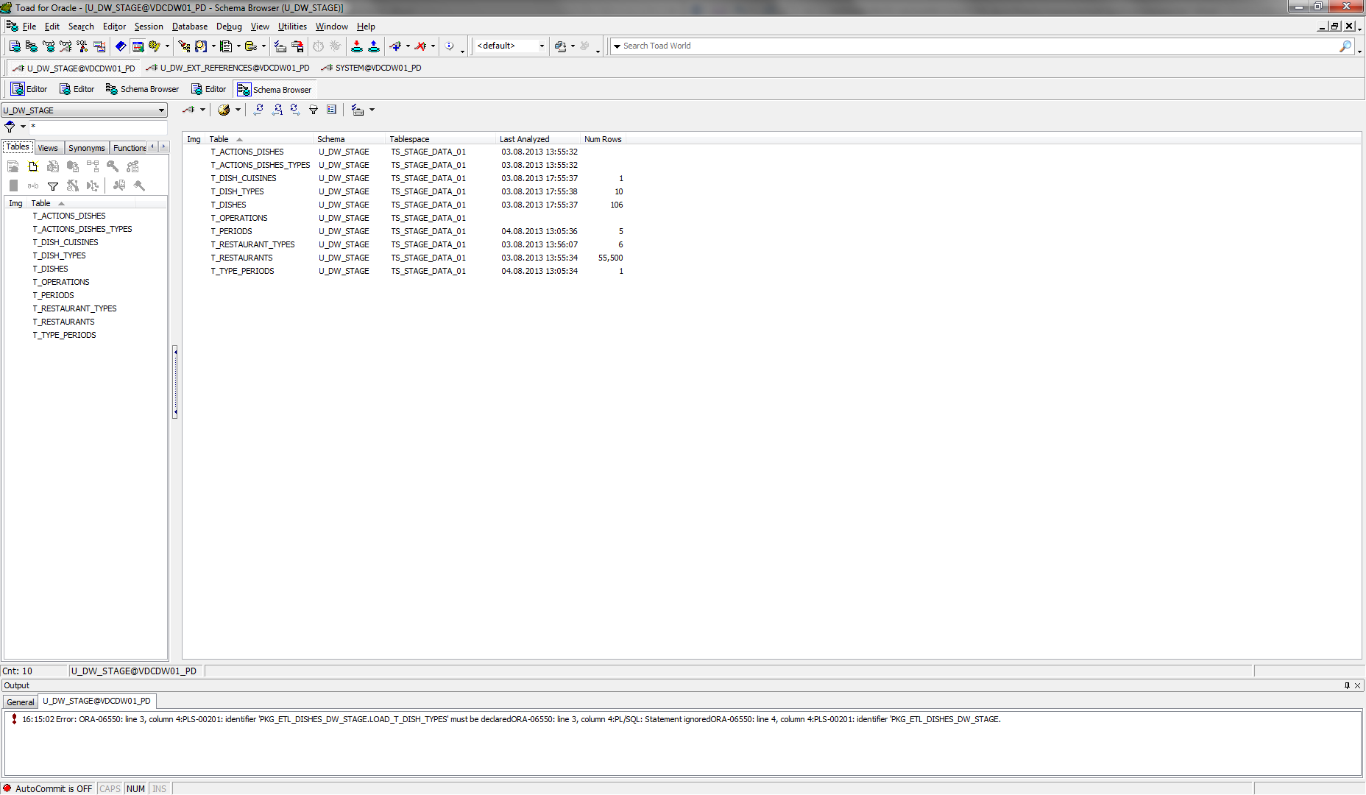

1. I have reload data to table T_OPERATIONS with using Merge (package *pkg_etl_operations_dw_stage*):

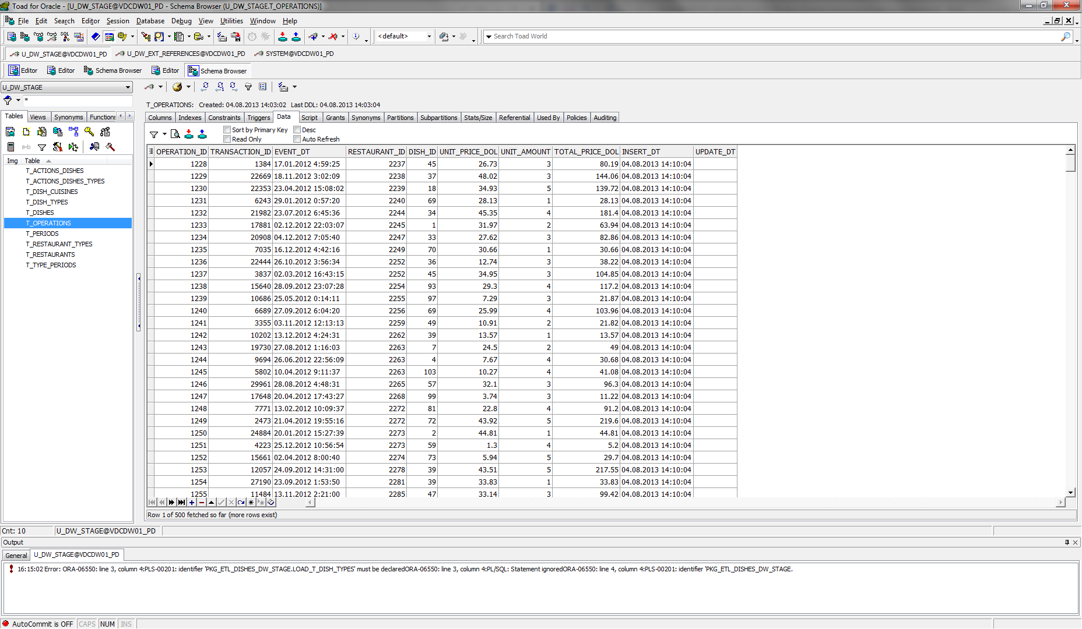

1. I have tested data for consistent. Scripts are in folder *test_data.*

( ( SELECT transaction_id

, event_dt

, restaurant_id

, dish_id

, unit_price_dol

, unit_amount

, total_price_dol

FROM t_operations )

MINUS

( SELECT transaction_code

, event_dt

, t_restaurants.restaurant_id

, t_dishes.dish_id

, unit_price_dol

, unit_amount

, total_price_dol

FROM u_dw_ext_references.cls_operations t

LEFT JOIN t_restaurants

ON t_restaurants.restaurant_code = t.restaurant_code

LEFT JOIN t_dishes

ON t_dishes.dish_code = t.dish_code ) )

UNION ALL

( ( SELECT transaction_code

, event_dt

, t_restaurants.restaurant_id

, t_dishes.dish_id

, unit_price_dol

, unit_amount

, total_price_dol

FROM u_dw_ext_references.cls_operations t

LEFT JOIN t_restaurants

ON t_restaurants.restaurant_code = t.restaurant_code

LEFT JOIN t_dishes

ON t_dishes.dish_code = t.dish_code )

MINUS

( SELECT transaction_id

, event_dt

, restaurant_id

, dish_id

, unit_price_dol

, unit_amount

, total_price_dol

FROM t_operations ) );

